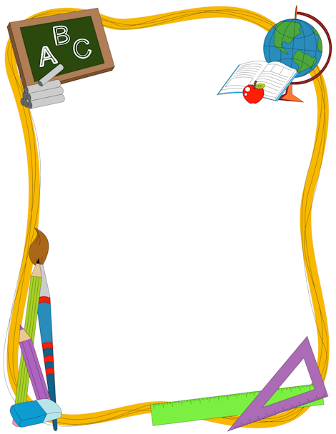

**Welcome!!!**

Welcome to our monthly newsletter which will keep you informed about what is happening in the school each month and tell you how you may become involved in the life of the nursery. We need your help and co-operation so that your child may enjoy his/her year at nursery school and gain the maximum benefit from this first step into education.

**School Phone Number—(028) 90745672.**

Please save this number for emergencies.

**Car Parking**

Parents leaving or collecting their child by car are requested to park their cars in Herbert Street/Flax Street and walk to the nursery via Butler Walk, using the nursery gate to gain access to the school.

**Cars must not be parked in front of Holy Cross Boys’ School gates.**

**Topics & Themes for September:** All About Me

Nursery Rhymes

**Maths for September:** Primary Colours

Exploring Circles

We ask parents to support our topics and themes by singing traditional nursery rhymes at bedtime and encouraging your child to talk about themselves.

**Healthy Eating**

As part of our healthy eating policy children receive a healthy snack of fruit and milk each day. We would ask you to support us by not allowing your child to bring sweets, crisps, juice or biscuits to school.

**Reminder**

Due to Education financial restraints we ask parents to kindly donate a box of tissues and Hand Sanitiser for children’s use in school. Thank you.

**Change of Clothes**

In case of “little accidents”, please leave a change of clothes in your child’s blue kit bag in the hall. These bags must remain in school.

Please ensure your child’s name is clearly marked on jumpers, coats, hats etc…

**The school cannot be responsible for lost or missing items.**

**SEPTEMBER NEWS**



**All About Me’ Files**

Throughout the year we record children’s achievements with parents in individual files. Your initial school fund payment of £5 will cover the cost of the file. At the end of the school year parents keep these files as a record of their child’s nursery year.

**Dinner/School Funds Money**

Dinners cost £2.50per day = £12.50 per week for those on paid dinners.

School fund money is £5.00 per week. Named bags are in your child’s individual Tray on Monday and should be posted in the Money Box outside the Classroom door no later than Wednesday.

**Settling In**

Parents are requested to stay on the school premises in the first week. Mrs Hanna will be in the Parents’ Room each morning to help with log-in to the ‘See-Saw’ App and explain the ‘All About Me’ Files.

**Screen Time**

We appreciate children enjoy and benefit from technology on Ipads and tablets, but we encourage parents to limit the time spent on these devices. Always be aware of what your child is watching, making sure it is age appropriate.

There are many alternative things you can do with your child and spend hours of fun together. For example, if you would like to make Play Dough at home with your child here is the recipe:-

**Play Dough Recipe:**

2 cups of flour 1 cup of salt

1 cup of water 1 tbsp cream of tartar

1 tbsp cooking oil A few drops of food colouring

Put flour, salt, cooking oil and cream of tartar into a saucepan and mix together. Add water and any colouring, while stirring over a low heat until ingredients form a dough-like consistency. Allow to cool before use.

**Prayer of the Month**

**Sign of the Cross.**

In the name of the Father

And of the Son

And of the Holy Spirit, Amen.

**September Birthdays**

Liam – 2nd , Zoey – 2nd Shea – 11th, Sophia – 18th

Conan – 12th, Farah – 21st, Cara -24th John Jay 28th

