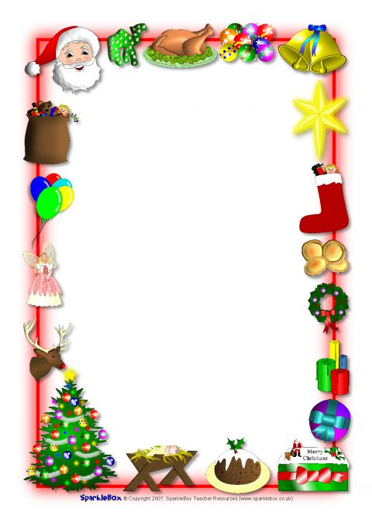

 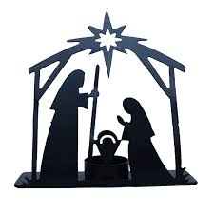

**Topic & Themes**

This month’s Topics are The Nativity and Christmas.

Colours are silver and gold and the shape is a star.

This Christmas in nursery it will be a little different; we will miss not being able to visit the local primary schools to watch Nativity plays or go on a trip to the Christmas Market.

However, we aim to give the children a magical Christmas. We have put our decorations up earlier than usual and the children are busy practicing for their Nativity Play which will be sent to everyone through Seesaw.

At present, we are due to finish at 11.00am on the 22nd December. This could very likely be moved forward – therefore we are making sure key events in December take place in the first two weeks.

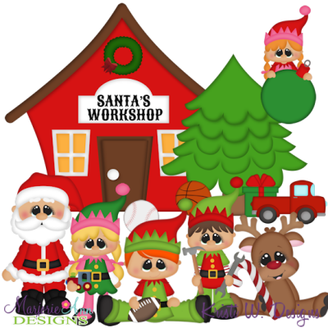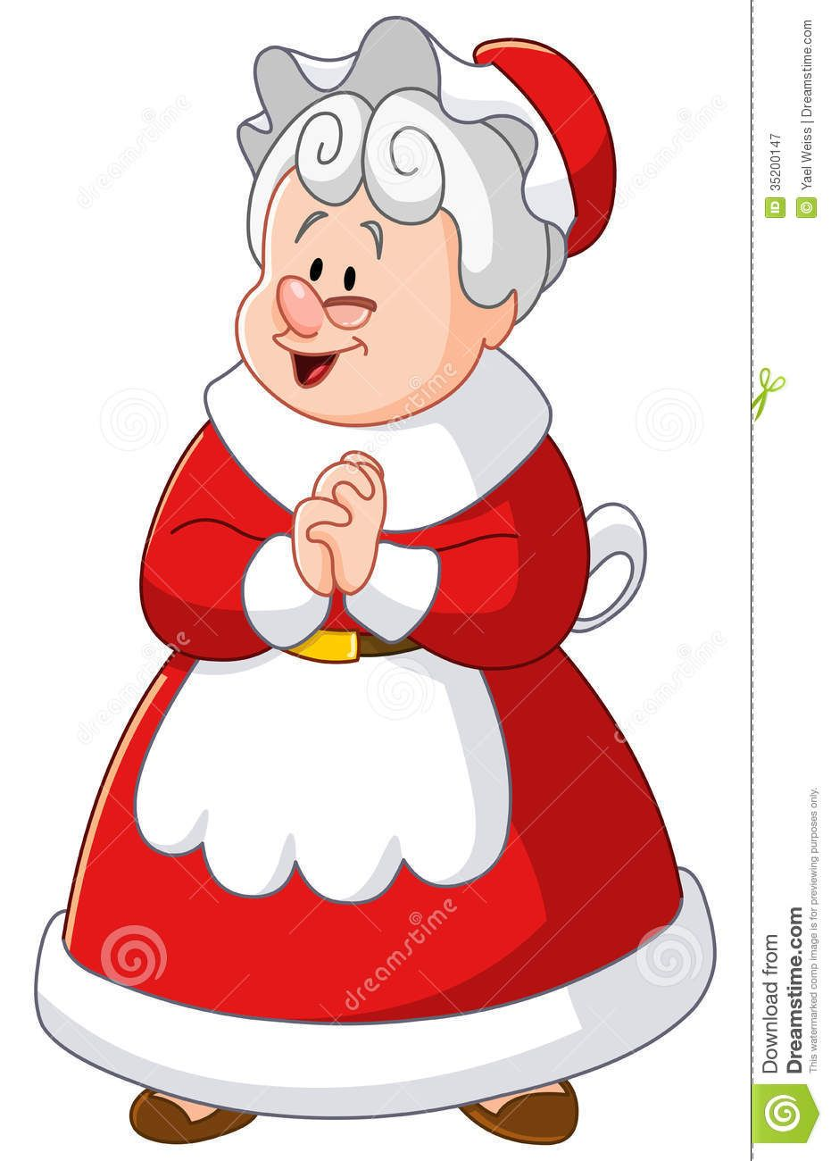

**Week beginning 7th**

We will have a virtual visit from Mrs Claus and some of the Elves. She will take us on a tour of Santa’s Workshop and show us how busy everyone is getting ready for Christmas Eve!

**Christmas Nativity Play**

**Wednesday 9th:** Room 1

**Thursday 10th:** Room 2

**Thursday 10th: Christmas Dinner**

Children will enjoy a Fun Christmas Dinner. Children are encouraged to wear a Christmas jumper to nursery on this day.

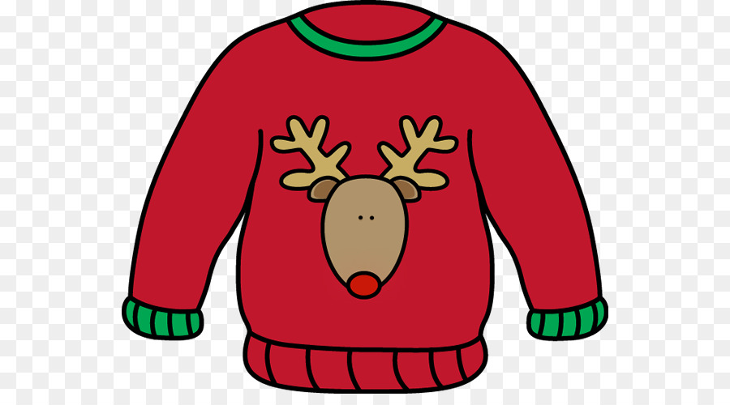

**Friday 11th: Christmas Jumper Day & Christmas Party Day**

Children can dress up in their Christmas Jumper and pay £1 to raise funds for Save the Children.

Santa will visit the children in his bright red bus and he might even have a present for them.

The Nativity Play will be recorded and sent to everyone – we will also send you a picture of your child in costume.

**December News**



**Housekeeping**

At this time of year the children will no doubt have runny noses, please ensure your child can wipe their own nose with a tissue and if your child is sick that they stay at home, this gives the children a chance to recover properly and stops germs from spreading. Please remember to put a warm coat on your child each day. Unless it is raining we are outside.

**Dump Your Dummy**

Before Christmas is the perfect opportunity to get rid of all Dummies and Bottles! Some Elves will be in the porch collecting them. They will take them back to Santa who will give them a Special Certificate for being a big boy/girl.

**Christmas Ballot**

Tickets are available from your child’s teacher.

Prizes to include: Christmas hampers, Christmas cake, cuddly toys and other prizes galore!

**Tickets are £1 each or 6 for £5.**

Draw will take place after the Christmas Concert.

* **Please have the money for ballots in by Friday 4th December.**
* **More Ballot sheets are available for anyone who wants them.**

This year we are donating the proceeds to the charity T.A.M.H.I.

**Christmas Hamper**

As part of our Christmas Ballot we need donations for our Christmas Hamper of non-perishable food. Please leave any donations in the box in the hall and mark them off the list. Thank you

**Monday 21st:**

Children will finish at 11.45am and 12noon and will go home with a packed lunch

**Tuesday 22nd**: This will be our children's last day of term and they will enjoy a morning of fun and games. Children will finish at 11.00am

***The Principal, staff and Board of***

***Governors of Holy Cross Nursery***

***School wish you all a very happy and***

***Holy Christmas.***

**School reopens on Thursday 7th January.**

**Enrolment for September 2021**

The Education Authority portal

for online applications opens on

Thursday 7th January and an online

Video from school will be posted

on that date.

NURSERY FINISHES AT 11.00AM on FRIDAY 20th DECEMBER AND REOPENS ON MONDAY 6TH JANUARY AT 9.00AM

***The Principal, Staff and Board of Governors of Holy Cross Nursery School wish you all a very Happy and Holy Christmas***

**December Birthdays**

**Patrick and Maddex 14th**

**Ódhran 18th**

**Eva 26th**